1. **ABOUT HTML :-**

* HTML is the standard markup language for creating Web pages.
* HTML stands for Hyper Text Markup Language
* HTML is the standard markup language for creating Web pages
* HTML describes the structure of a Web page
* HTML consists of a series of elements
* HTML elements tell the browser how to display the content
* HTML elements label pieces of content such as "this is a heading", "this is a paragraph", "this is a link", etc.

1. **BOILERPLATE:-**A simple HTML document.

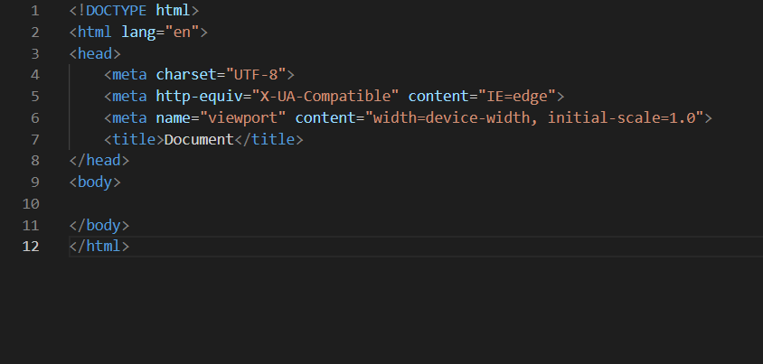

* The <!DOCTYPE html> declaration defines that this document is an HTML5 document.

## What is an HTML Element?

An HTML element is defined by a start tag, some content, and an end tag:

<tagname> Content goes here... </tagname>

* The <head> element contains meta information about the HTML page.
* The <title> element specifies a title for the HTML page (which is shown in the browser's title bar or in the page's tab)
* The <body> element defines the document's body, and is a container for all the visible contents, such as headings, paragraphs, images, hyperlinks, tables, lists, etc.

## HTML Headings :-

Search engines use the headings to index the structure and content of your web pages.

Users often skim a page by its headings. It is important to use headings to show the document structure.

<h1> headings should be used for main headings, followed by <h2> headings, then the less important <h3>, and so on.

HTML headings are defined with the <h1> to <h6> tags.

<h1> defines the most important heading. <h6> defines the least important heading.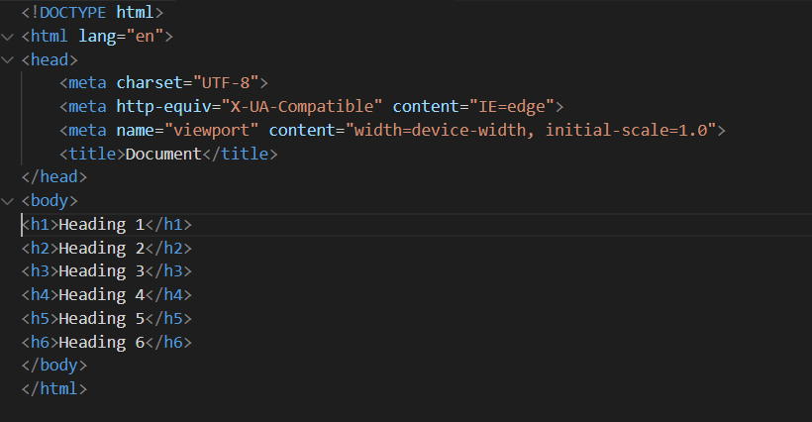

This is heading from h1 to h6.

## HTML Paragraphs :-

A paragraph always starts on a new line, and is usually a block of text.

The HTML <p> element defines a paragraph.

A paragraph always starts on a new line, and browsers automatically add some white space (a margin) before and after a paragraph.

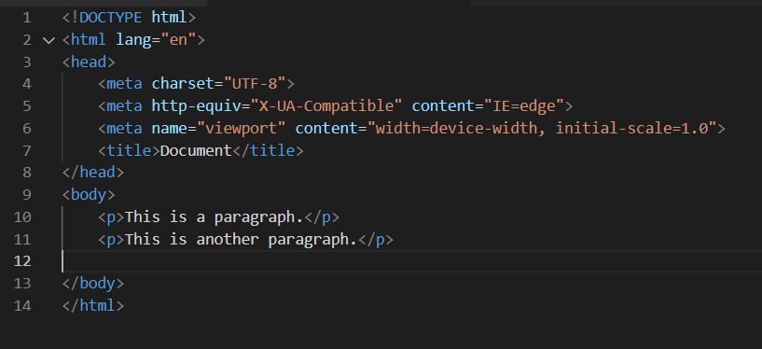

This is a paragraph.

1. **HTML Attributes :-**

* All HTML elements can have attributes
* Attributes provide additional information about elements
* Attributes are always specified in the start tag
* Attributes usually come in name/value pairs like: name="value"
* The href Attribute:-

The <a> tag defines a hyperlink. The href attribute specifies the URL of the page the link goes to:

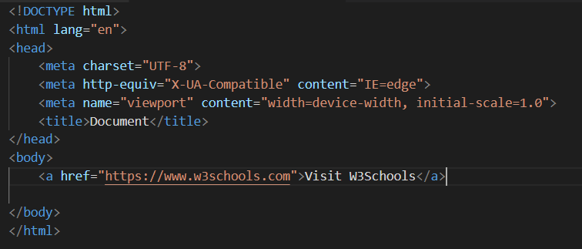

This is href attribute.

attribute.

## The src Attribute :-

The <img> tag is used to embed an image in an HTML page. The src attribute specifies the path to the image to be displayed.

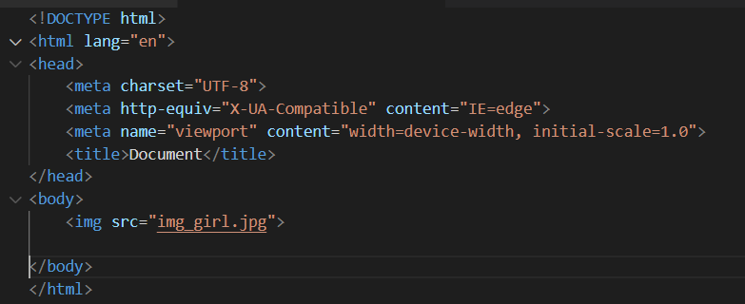

This is src attribute. 

There are two ways to specify the URL in the src attribute:

**1. Absolute URL** - Links to an external image that is hosted on another website. Example: src="https://www.w3schools.com/images/img_girl.jpg".

Notes: External images might be under copyright. If you do not get permission to use it, you may be in violation of copyright laws. In addition, you cannot control external images; it can suddenly be removed or changed.

**2. Relative URL** - Links to an image that is hosted within the website. Here, the URL does not include the domain name. If the URL begins without a slash, it will be relative to the current page. Example: src="img_girl.jpg". If the URL begins with a slash, it will be relative to the domain. Example: src="/images/img_girl.jpg".

Tip: It is almost always best to use relative URLs. They will not break if you change domain.

**3. HTML File Paths**:- A file path describes the location of a file in a web site's folder structure.

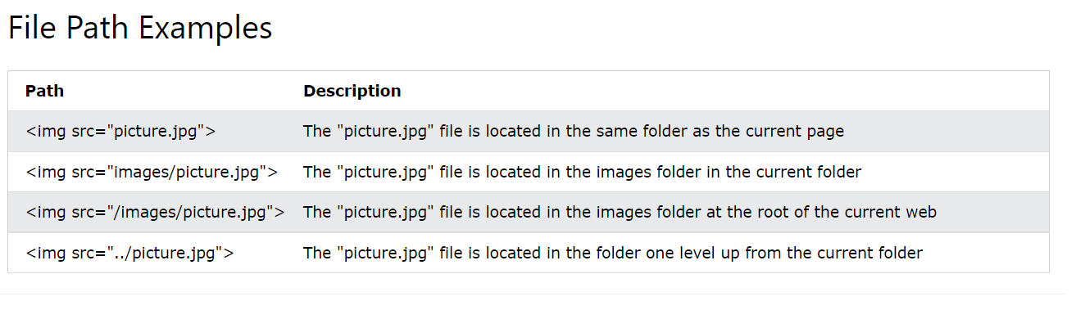

## The alt Attribute:-

The required alt attribute for the <img> tag specifies an alternate text for an image, if the image for some reason cannot be displayed. This can be due to a slow connection, or an error in the src attribute, or if the user uses a screen reader.

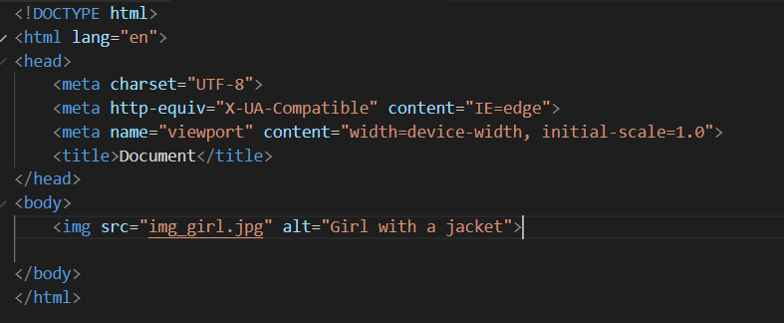

This is alt attribute. 

## The title Attribute:-

The title attribute defines some extra information about an element.

The value of the title attribute will be displayed as a tooltip when you mouse over the element:

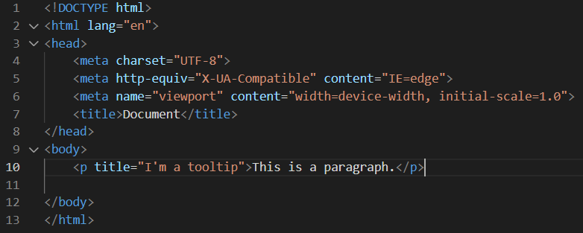

This is title attribute. 

## HTML Comment Tag :-

HTML comments are not displayed in the browser, but they can help document your HTML source code.

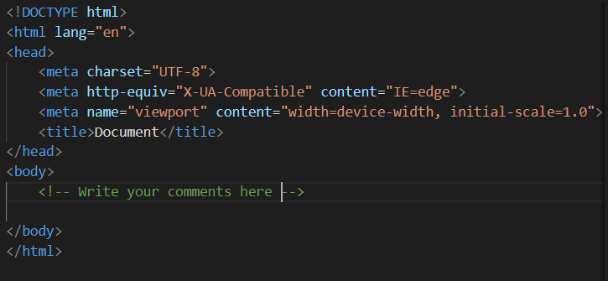

This is the comment tag.

## Add a Favicon in HTML :-

## A favicon image is displayed to the left of the page title in the browser tab, like this:

## 

This is a favicon.

To add a favicon to your website, either save your favicon image to the root directory of your webserver, or create a folder in the root directory called images, and save your favicon image in this folder. A common name for a favicon image is "favicon.ico".

Next, add a <link> element to your "index.html" file, after the <title> element, like this:

## 

This is the link to add favicon.

## External CSS :-

An external style sheet is used to define the style for many HTML pages.

To use an external style sheet, add a link to it in the <head> section of each HTML page:

## 

This is the link to add external Css.

# HTML Tables :-

HTML tables allow web developers to arrange data into rows and columns.

A table in HTML consists of table cells inside rows and columns.

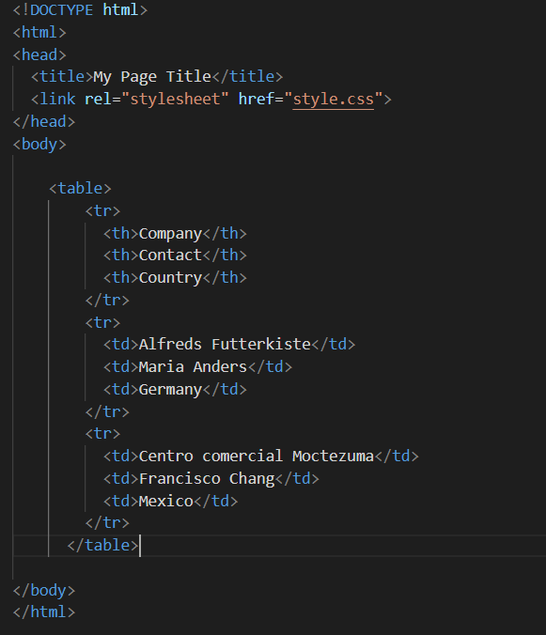

This is the table.

## Table Cells :-

Each table cell is defined by a <td> and a </td> tag.

td stands for table data.

Everything between <td> and </td> are the content of the table cell.



This is the table data cell where you should add the data to be displayed in the table.

## Table Rows :-

Each table row starts with a <tr> and ends with a </tr> tag.

tr stands for table row.



This is table row.

## Table Headers :-

Sometimes you want your cells to be table header cells. In those cases use the <th> tag instead of the <td> tag:

th stands for table header.



This is table header.

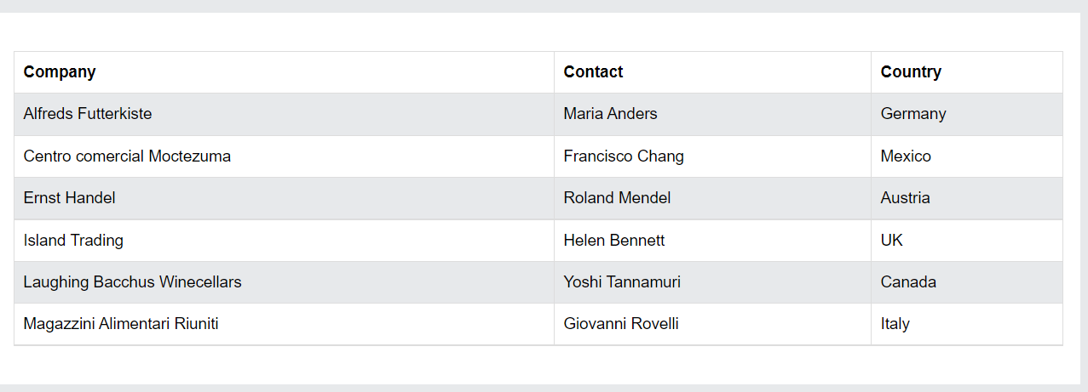

# HTML Lists :-

# HTML lists allow web developers to group a set of related items in lists.

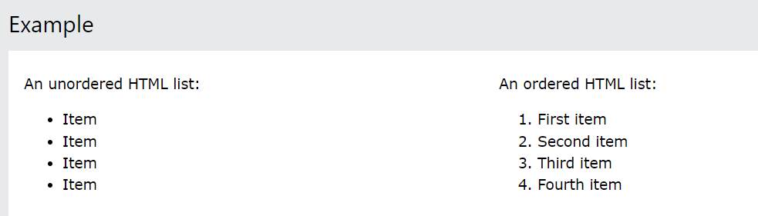

## Unordered HTML List :-

An unordered list starts with the <ul> tag. Each list item starts with the <li> tag. The list items will be marked with bullets (small black circles) by default:

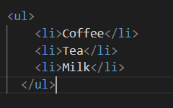

This is unordered list.

## Ordered HTML List

An ordered list starts with the <ol> tag. Each list item starts with the <li> tag.The list items will be marked with numbers by default:

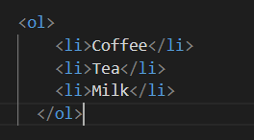

This is ordered list.

## HTML Description Lists

HTML also supports description lists.

A description list is a list of terms, with a description of each term.

The <dl> tag defines the description list, the <dt> tag defines the term (name), and the <dd> tag describes each term:

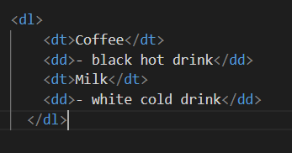

This is description list.

# HTML Block and Inline Elements:-

Every HTML element has a default display value, depending on what type of element it is.

There are two display values: block and inline.

## Block-level Elements :-

A block-level element always starts on a new line, and the browsers automatically add some space (a margin) before and after the element.

A block-level element always takes up the full width available (stretches out to the left and right as far as it can).

Two commonly used block elements are: <p> and <div>.

The <p> element defines a paragraph in an HTML document.

The <div> element defines a division or a section in an HTML document.

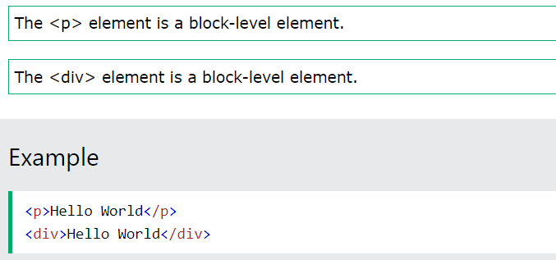

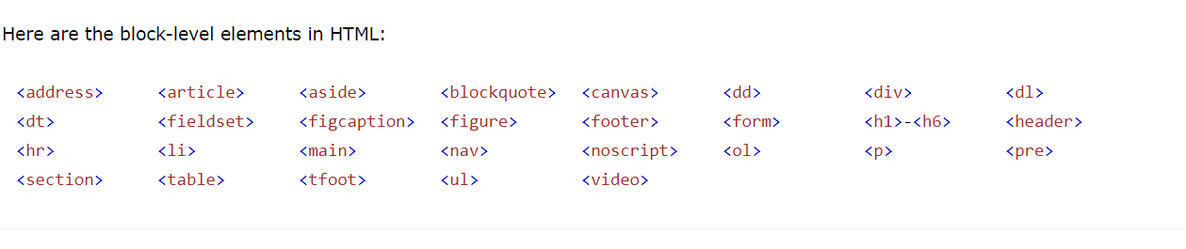

## Inline Elements :-

An inline element does not start on a new line.

An inline element only takes up as much width as necessary.

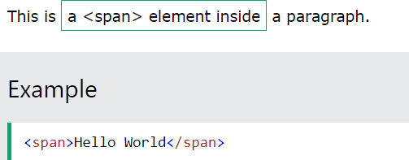

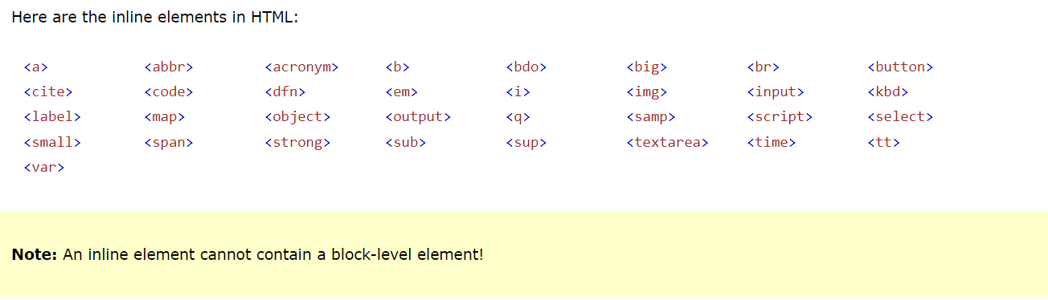

## The <div> Element :-

The <div> element is often used as a container for other HTML elements.

The <div> element has no required attributes, but style, class and id are common.

When used together with CSS, the <div> element can be used to style blocks of content:

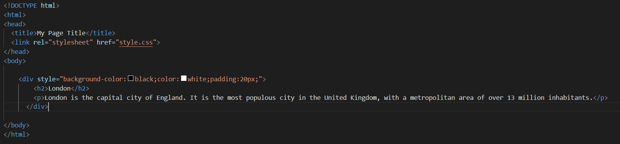

This is the div element.

## The <span> Element :-

The <span> element is an inline container used to mark up a part of a text, or a part of a document.

The <span> element has no required attributes, but style, class and id are common.

When used together with CSS, the <span> element can be used to style parts of the text:



This is the span element.

# HTML class and Id Attribute:-

The HTML class attribute is used to specify a class for an HTML element.

Multiple HTML elements can share the same class.

## Using The class Attribute

The class attribute is often used to point to a class name in a style sheet. It can also be used by a JavaScript to access and manipulate elements with the specific class name.

In the following example we have three <div> elements with a class attribute with the value of "city". All of the three <div> elements will be styled equally according to the .city style definition in the head section:

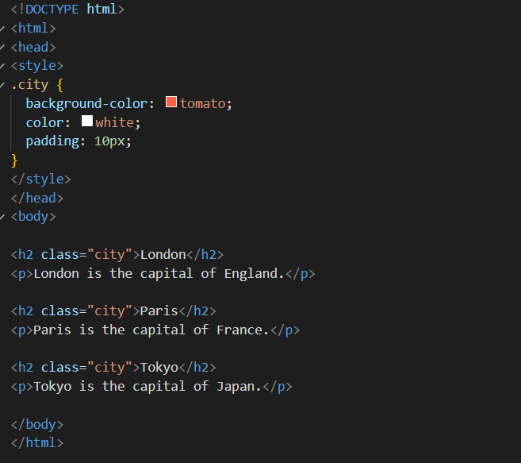

This is a class which is defined as city.

## To create a class; write a period (.) character, followed by a class name. Then, define the CSS properties within curly braces {}:

## Multiple Classes

HTML elements can belong to more than one class.

To define multiple classes, separate the class names with a space, e.g. <div class="city main">. The element will be styled according to all the classes specified.

In the following example, the first <h2> element belongs to both the city class and also to the main class, and will get the CSS styles from both of the classes:

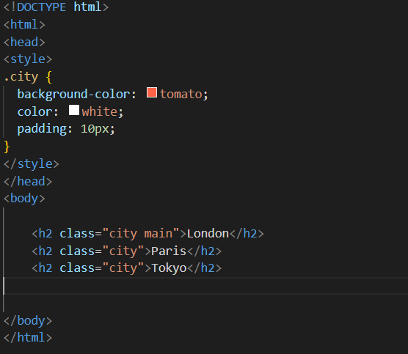

Here there are two classes defined the first one is city main and second is city.

* Using the Id attribute :-
* The syntax for id is: write a hash character (#), followed by an id name. Then, define the CSS properties within curly braces {}.
* In the following example we have an <h1> element that points to the id name "myHeader". This <h1> element will be styled according to the #myHeader style definition in the head section:

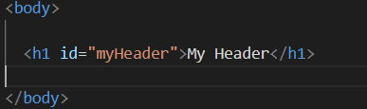

This is the id attribute.

Note :- The id name is case sensitive!

Note :- The id name must contain at least one character, cannot start with a number, and must not contain whitespaces (spaces, tabs, etc.).

1. HTML Iframes:-

The HTML <iframe> tag specifies an inline frame.

An inline frame is used to embed another document within the current HTML document.

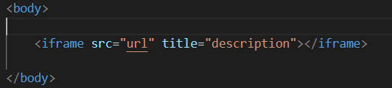

This is a Iframe syntax.

## Iframe - Target for a Link

An iframe can be used as the target frame for a link.

The target attribute of the link must refer to the name attribute of the iframe:

Here we have used “src” to access the iframe from source.

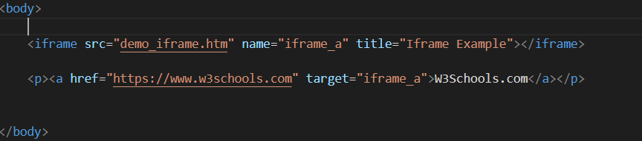

Here we have used “href ” to access the iframe from the link.

1. **HTML FORMS :-**

An HTML form is used to collect user input. The user input is most often sent to a server for processing.

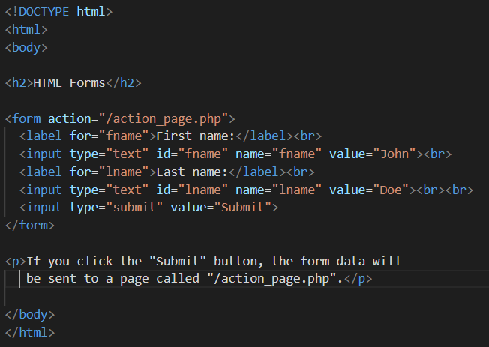 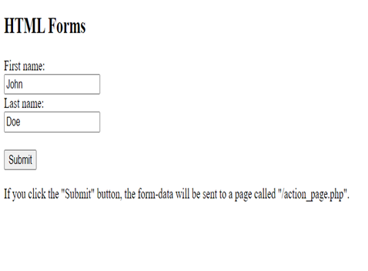

* **The Action Attribute:-** The action attribute defines the action to be performed when the form is submitted.

Usually, the form data is sent to a file on the server when the user clicks on the submit button.

In the example below, the form data is sent to a file called "action_page.php". This file contains a server-side script that handles the form data:

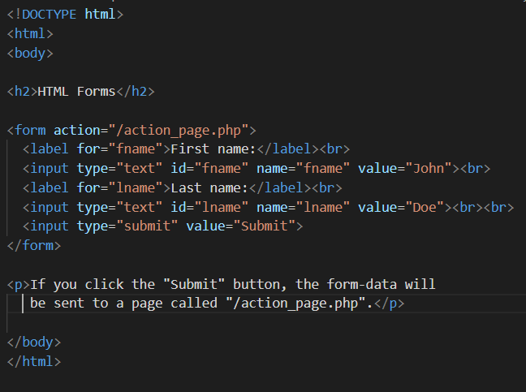 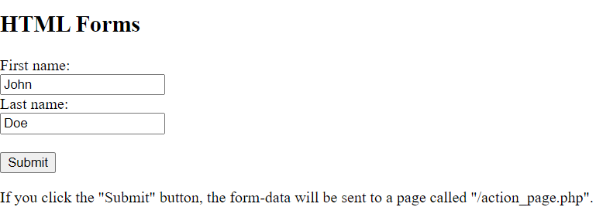

* **The Target Attribute :-** The target attribute specifies where to display the response that is received after submitting the form. The target attribute can have one of the following values:

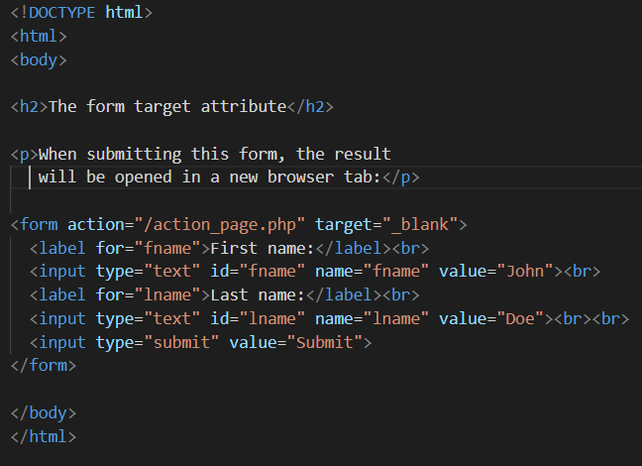 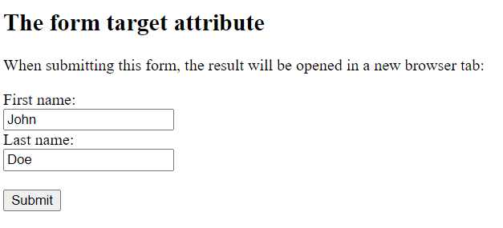

* **The <input> Element :-** One of the most used form element is the <input> element. The <input> element can be displayed in several ways, depending on the type attribute.

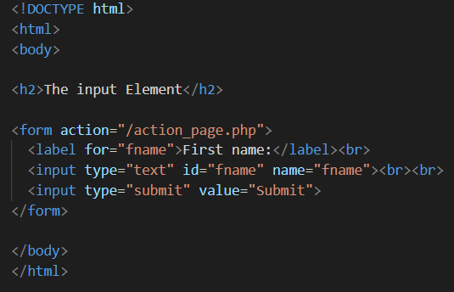 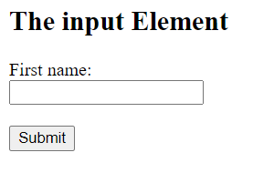

* **The <label> , <select> and <option> Element :-** The <label> element defines a label for several form elements.
* The <label> element is useful for screen-reader users, because the screen-reader will read out loud the label when the user focus on the input element.
* The <label> element also help users who have difficulty clicking on very small regions (such as radio buttons or checkboxes) - because when the user clicks the text within the <label> element, it toggles the radio button/checkbox.
* The for attribute of the <label> tag should be equal to the id attribute of the <input> element to bind them together.
* The <select> element defines a drop-down list.
* The <option> elements defines an option that can be selected. By default, the first item in the drop-down list is selected. To define a pre-selected option, add the selected attribute to the option.

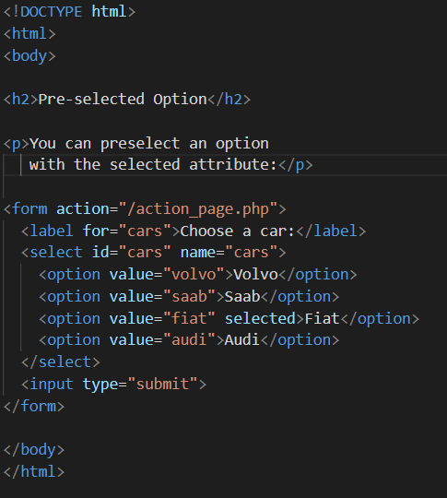 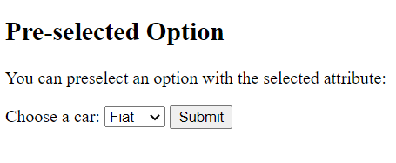

**Write the following code in your VS Code to see the result.**

## HTML Input Types :-

Here are the different input types you can use in HTML:

## Input Type Text :-

<input type="text"> defines a **single-line text input field**:

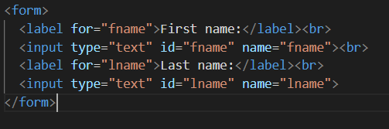

## Input Type Password

**<input type="password"> defines a password field:**

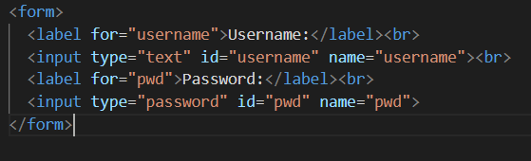

## Input Type Submit :-

<input type="submit"> defines a button for **submitting** form data to a **form-handler**.

The form-handler is typically a server page with a script for processing input data.

The form-handler is specified in the form's action attribute:

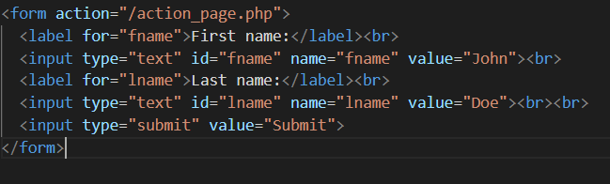

## Input Type Reset :-

<input type="reset"> defines a **reset button** that will reset all form values to their default values:

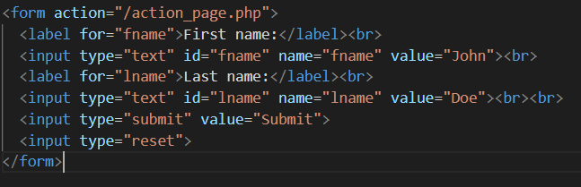

## Input Type Radio :-

<input type="radio"> defines a **radio button**.

Radio buttons let a user select ONLY ONE of a limited number of choices:

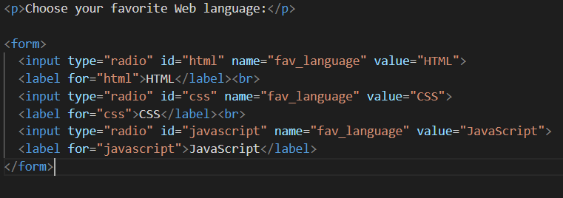

## Input Type Checkbox :-

<input type="checkbox"> defines a **checkbox**.

Checkboxes let a user select ZERO or MORE options of a limited number of choices.

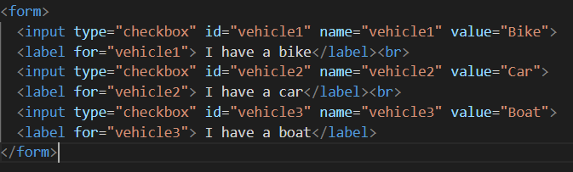

## Input Type Button :-

<input type="button"> defines a **button**:



## Input Type Color :-

The <input type="color"> is used for input fields that should contain a color.

Depending on browser support, a color picker can show up in the input field.

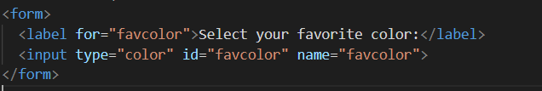

## Input Type Date :-

The <input type="date"> is used for input fields that should contain a date.

Depending on browser support, a date picker can show up in the input field.

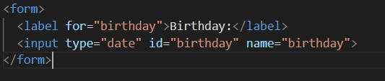

## Input Type Datetime-local :-

The <input type="datetime-local"> specifies a date and time input field, with no time zone.

Depending on browser support, a date picker can show up in the input field.

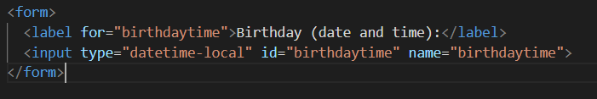

## Input Type Email :-

The <input type="email"> is used for input fields that should contain an e-mail address.

Depending on browser support, the e-mail address can be automatically validated when submitted.

Some smartphones recognize the email type, and add ".com" to the keyboard to match email input.

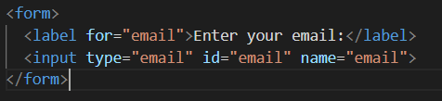

## Input Type Image :-

The <input type="image"> defines an image as a submit button.

The path to the image is specified in the src attribute.

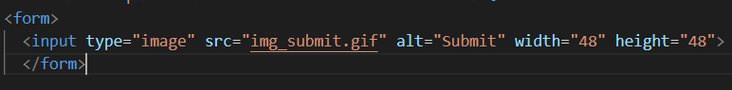

## Input Type File :-

The <input type="file"> defines a file-select field and a "Browse" button for file uploads.

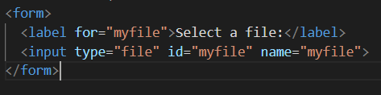

## Input Type Hidden :-

The <input type="hidden"> defines a hidden input field (not visible to a user).

A hidden field lets web developers include data that cannot be seen or modified by users when a form is submitted.

A hidden field often stores what database record that needs to be updated when the form is submitted.

**Note:** While the value is not displayed to the user in the page's content, it is visible (and can be edited) using any browser's developer tools or "View Source" functionality. Do not use hidden inputs as a form of security!

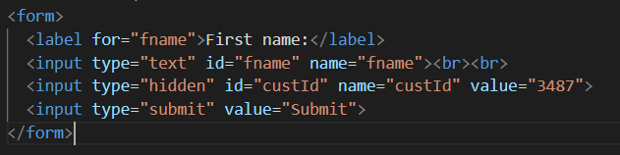

## Input Type Month :-

The <input type="month"> allows the user to select a month and year.

Depending on browser support, a date picker can show up in the input field.

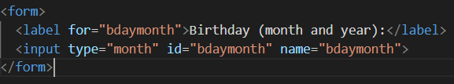

## Input Type Number :-

The <input type="number"> defines a **numeric** input field.

You can also set restrictions on what numbers are accepted.

The following example displays a numeric input field, where you can enter a value from 1 to 5.

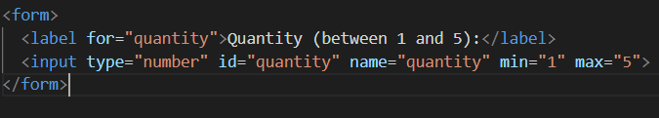

## Input Type Range :-

The <input type="range"> defines a control for entering a number whose exact value is not important (like a slider control). Default range is 0 to 100. However, you can set restrictions on what numbers are accepted with the min, max, and step attributes:

